**Middleware**

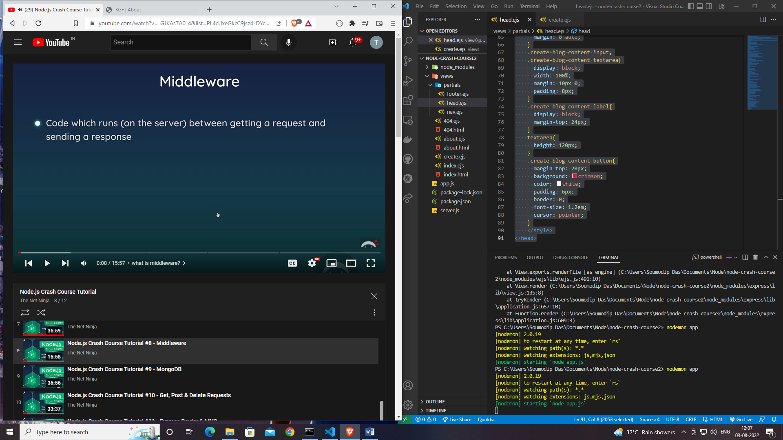

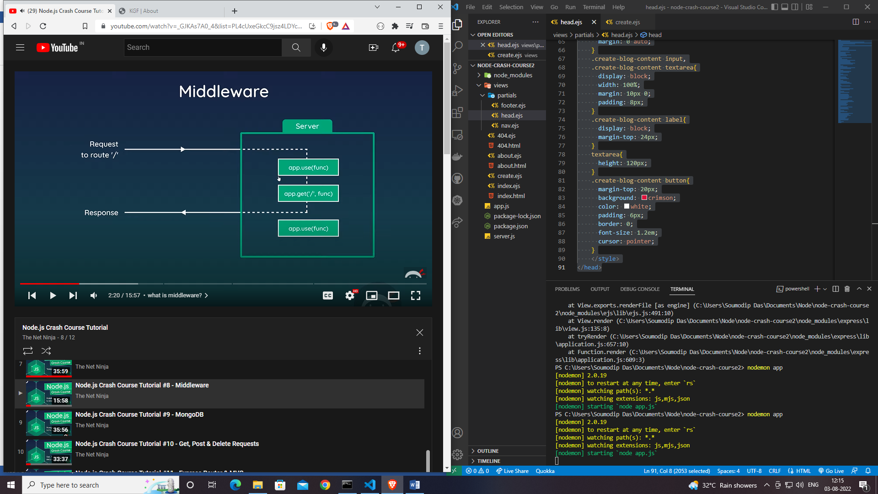

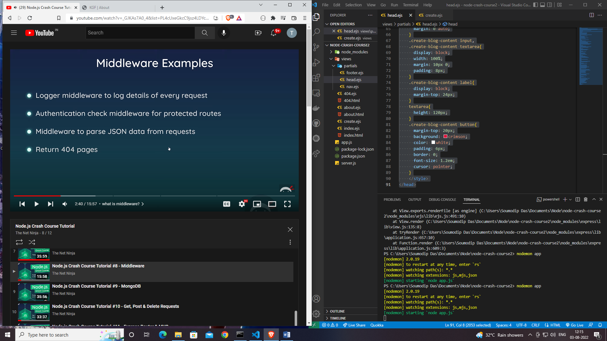

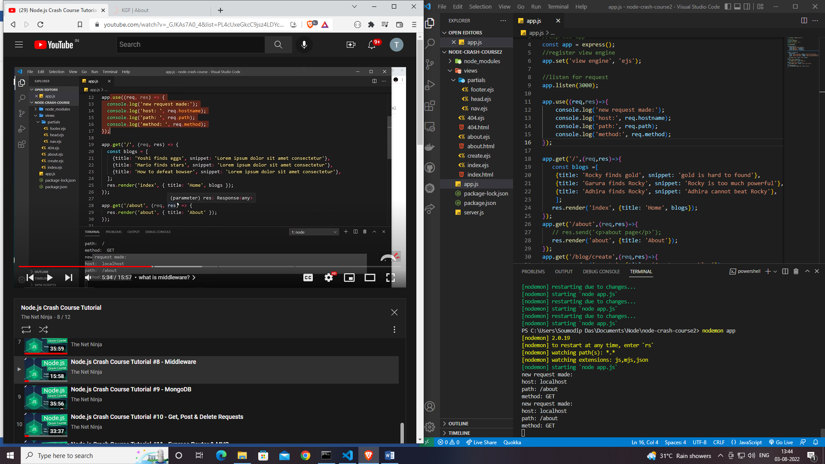

**Using next()**

app.use((req,res,next)=>{

    console.log('new request made:');

    console.log('host:', req.hostname);

    console.log('path:', req.path);

    console.log('method:', req.method);

    next();

});

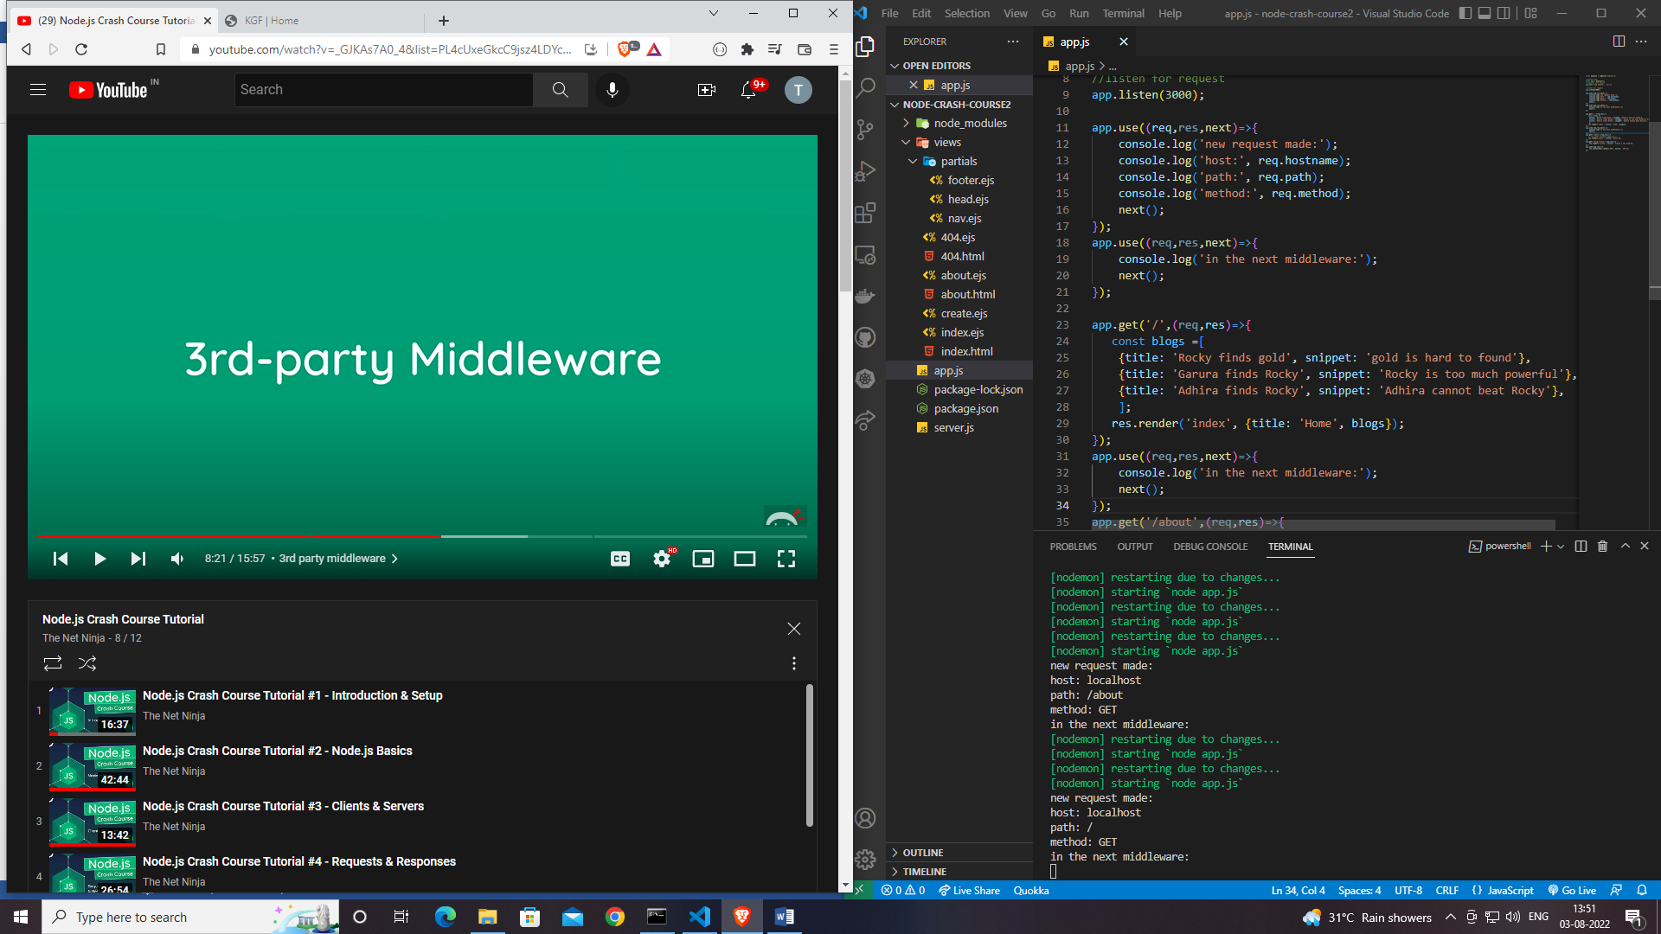

**3rd Party Middlewere**

**npm install morgan**

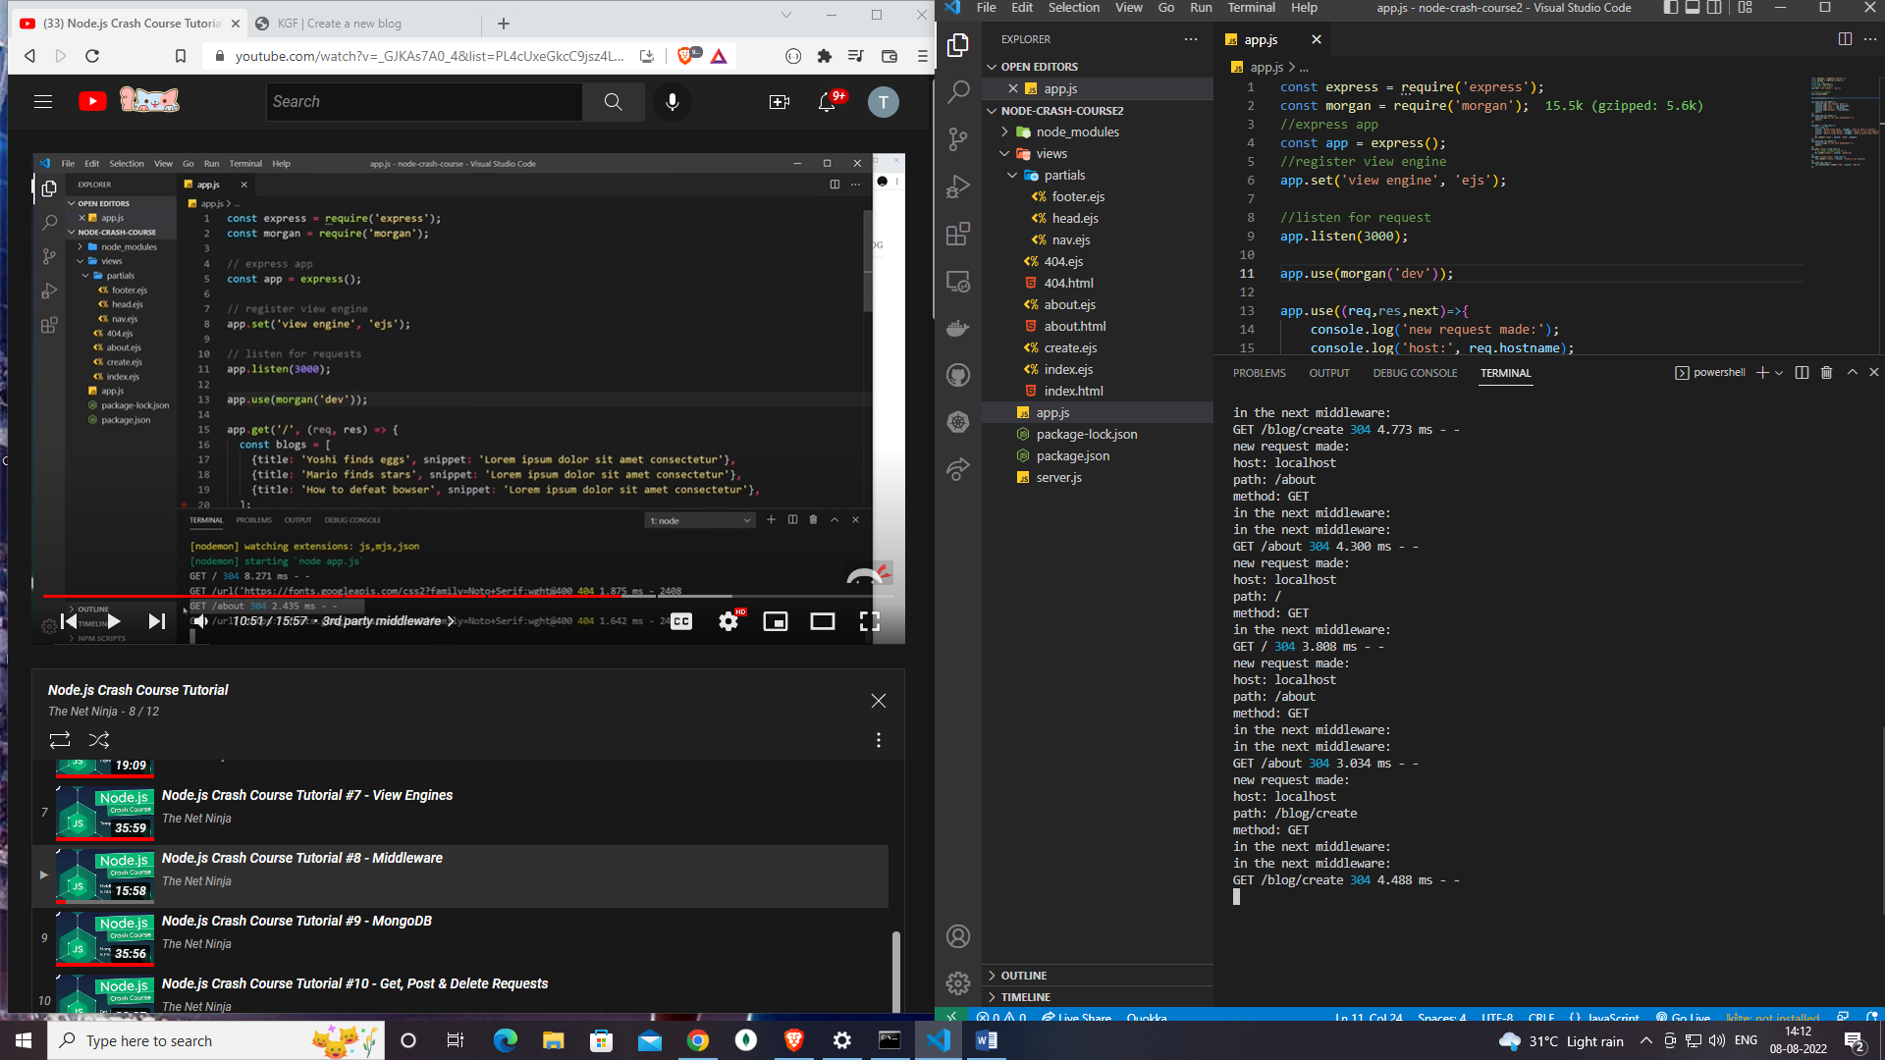

**Static Files**

const morgan = require('morgan');

app.use(express.static('public'));